**CIS 572 Object Oriented System Design**

**Forward Tracing**

for

**Providing service to the member**



Submitted to:  Mr. Thomas Steiner

Submitted by: ~~Khushmeet Kaur~~ Maxx Achtman

~~UMID 10705136~~

**Table of Contents**

USE CASE FLOW **3**

7.1 Provider provides the services to members: 3

USE CASE DIAGRAM **3**

BUILD ERD **4**

ROBUSTNESS DIAGRAM **5**

COMMUNICATION DIAGRAM **5**

SEQUENCE DIAGRAM **6**

CLASS DIAGRAM **6**

DFD **7**

STATE DIAGRAM **8**

CRC CARD **8**

# USE CASE FLOW

## 7.1 Provider provides the services to members:

1. Member swipes his member card.
2. The provider looks into the provider directory for the list of services.
3. The provider then provides services to the member.
4. The provider looks into the provider directory again to verify the service details.
5. The provider swipes the member card for bill purpose.

# USE CASE DIAGRAM

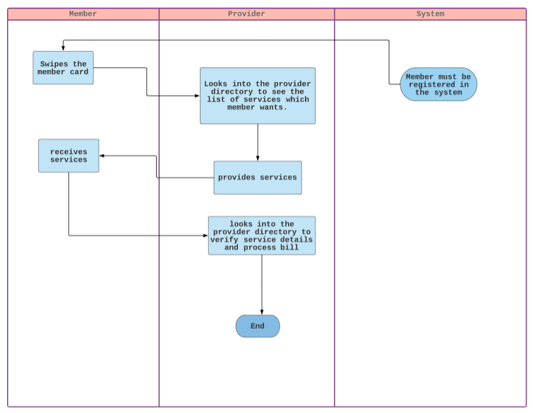

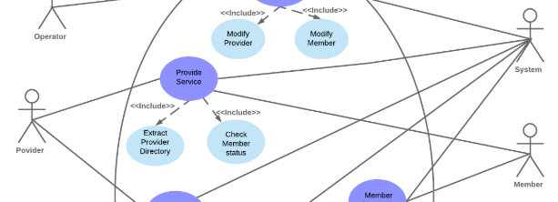

# 

# BUILD ERD

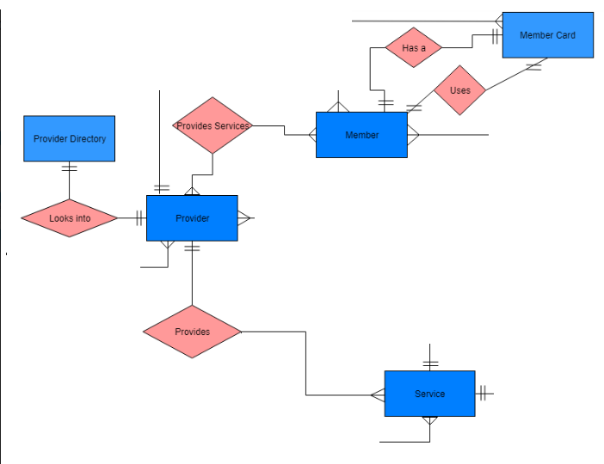

# ROBUSTNESS DIAGRAM

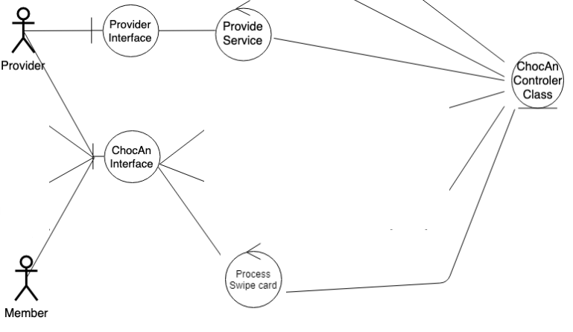

# COMMUNICATION DIAGRAM

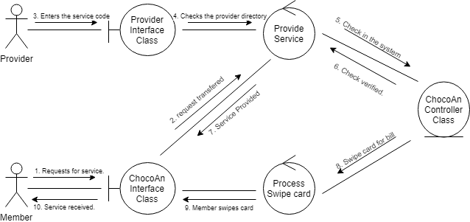

# SEQUENCE DIAGRAM

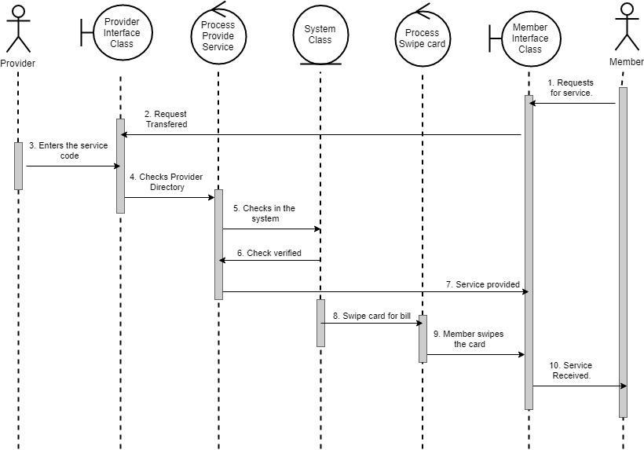

# CLASS DIAGRAM

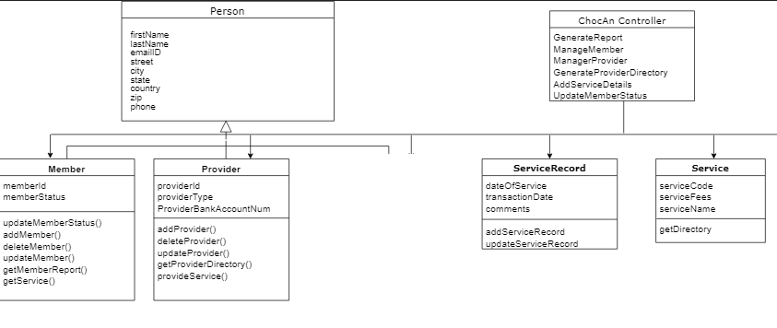

# DFD

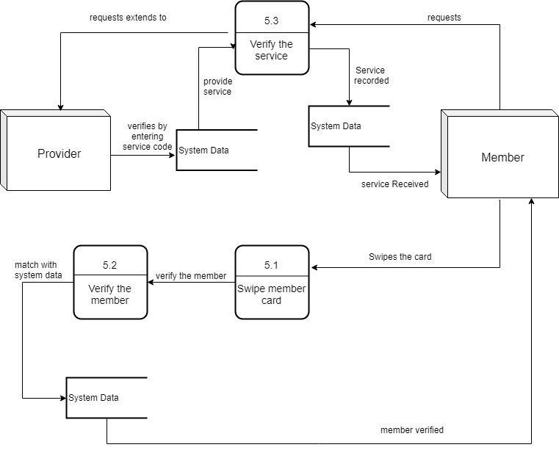

# STATE DIAGRAM

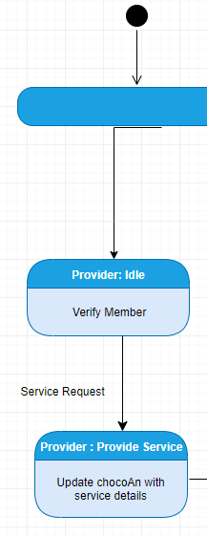

# CRC CARD

